

Operating Instructions
ProMinent® CO2 Feeder

CO2 - ProMinent – P/N: 7746944 (Revision C), Date 09-14-12

Please completely read through these operating instructions first! Do not discard!
The warranty shall be invalidated by damage caused by operating errors!

ProMinent Fluid Controls, Inc. (USA) 136 Industry Drive, Pittsburgh, PA 15275
Tel: (412) 787-2484 www.prominent.us Fax: (412) 787-0704

TABLE OF CONTENTS

Introduction
- Overview 3
- CO2 Feeders 4

1.0 Installation & Quick Start Guide
- Safety 7
- Delivery & Storage Checklist 7
- Installation Guidelines 8
- Quick Start Guide 9
- Servicing Guidelines 10

2.0 Troubleshooting & Spare Parts
  - Troubleshooting Guide 11
  - Spare Parts 12

Appendix
- Mech. / Elec. Layout & Bill of Material 30
- Reference Documents 43
- Accessories

INTRODUCTION

- Overview:

The ProMinent CO2 Feeder is designed to utilize bottled Carbon Dioxide (CO2) in the control of pH levels in pools and spas.

Research has shown that there are a number of advantages when using CO2 for pH control compared to acid. Adding CO2 will not contribute to a TDS increase in water, thus reducing the amount of make-up water required to maintain the water quality. It is much safer, as there is no mineral acid solution or fumes present on-site, which solves the problems associated with handling acid. It is also simple to install and operate.

The ProMinent CO2 Feeder is equipped with all the necessary components for easy installation, reliable performance and safe operation. The design incorporates an electric solenoid valve and a manually adjustable flowmeter.

Accessories available are CO2 diffusers (contains injection valve, check valve and diffuser), CO2 eductor, pressure regulators, heaters and manifold assemblies.

- CO2 Feeders:

Part Number | Description & Feed-rate
7746991 | CO2-50 Feed Unit, 5-50 SCFH
7746928 | CO2-200 Feed Unit, 20-200 SCFH
7746992 | CO2-50E Feed Unit, 5-50 SCFH w/Eductor | (Consists of P/N: 7746991 + P/N: 7746942)
7746993 | CO2-50D Feed Unit, 5-50 SCFH w/Diffuser | (Consists of P/N: 7746991 + P/N: 7746926)
7746931 | CO2-200E Feed Unit, 20-200 SCFH w/Eductor | (Consists of P/N: 7746928 + P/N: 7746942)

Overall Feeder Dimensions 8.2”H x 7.4”W x 7.5”D (w/Mtg. Feet)
Overall Weight of Feeder < 5 lbs.
Power Requirements 120VAC, 60Hz, 1 Phase, 15 Amp
Maximum Volume 5-50 SCFH or 20-200 SCFH
Maximum Pressure 100 PSIG
Normal Operating Pressure 40 PSIG
Recommended Running Temperature +40°F to 100°F
Inlet Connection Size 3/8” OD Tube
Outlet Connection Size 3/8” OD Tube

1.0 INSTALLATION & QUICK START GUIDE

1.1 Safety:

Utilize appropriate protective safety gear when operating or maintaining this equipment. Recommended safety gear is as follows:

Personal Protective Equipment (PPE):
- Safety Glasses with side shields
- PVC Gloves

1.2 Delivery & Storage Checklist:

- Check packing list for completeness and note any missing items immediately.
- Inspect equipment and shipping container for damages before accepting delivery. Make note of the carrier’s bill-of-lading the extent of the damage, if any, and notify the carrier.
- Store the equipment on firm level surface in original packing container. Do not store the equipment where it may be exposed to extreme temperatures, precipitation, humidity, or dust. Avoid direct sunlight that could overheat and damage equipment.

Ambient Conditions for storage and transport:
Temperature: 15°F to 130°F
Air Humidity: ≤ 92% relative humidity, non-condensing

1.3 Installation Guidelines:

- Unpack and Check the tightness of all fittings.
- Position equipment and securely mount on a solid wall surface at a convenient height to access control knobs.
- The CO2 Feeder should be installed as close to the pH controller as possible.
- Do not install equipment in areas of extreme heat, cold, dust or humidity. Avoid areas where objects or fluids can drop from overhead.
- Electrical Supply Needed for the System:
Note: Review local Electrical Code and follow accordingly.
- Plug the supplied power cord from the feeder into a properly grounded receptacle. (120VAC, Single Phase, 15 Amp, 60 Hz)
- Check electrical connections to be sure proper voltage is supplied to the system.
- Do not put conduit entries in the top of the control panel. Resulting conduit condensation and failure to seal may damage internal components.
- Install CO2 Heater on the CO2 cylinder if required. Heater is required on all 20-200 SCFH sized Feeders. This is required because CO2 freezes due to pressure drop. Ensure fittings are tight to prevent leaks.
- Connect a Pressure Regulator (or Pressure Regulator Manifold if supplied) on the CO2 cylinder. Ensure fittings are tight to prevent leaks.
- Connect 3/8” OD PE Tube from the Pressure Regulator on the CO2 cylinder to the inlet of the Feeder.
- Connect 3/8” OD PE Tube from the outlet of the Feeder to the appropriate diffuser or eductor. Utilize PTFE tape (not pipe joint compound) on the threads of the diffuser/eductor.

1.4 Quick Start Guide:

- Slowly open the gas cylinder valve.
- Set the output pressure on cylinder (Inlet to CO2 Feeder) to the desired pressure by adjusting the pressure regulator knob. Do not exceed 100 psig into the feeder.
- Switch the CO2 feeder to the “ON” position to energize the solenoid.
- Adjust the rotometer until the desired flow rate is needed. Flow rate will be 5-50 SCFH or 20-200 SCFH depending on the model.

1.5 Servicing Guidelines:

- Disconnect electrical power to the equipment prior to servicing.
- Relieve all pressure from the unit prior to servicing.
- Close all cylinder valves.

Ensure all operating & maintenance personnel are instructed regarding the contents of this manual.
2.0 TROUBLESHOOTING & SPARE PARTS

2.1 Troubleshooting Guide

The following is a guide to assist during commissioning of the CO2 Feeder.

SYMPTOM | POSSIBLE CAUSE | CORRECTIVE ACTION
No Gas Feed | Output pressure too low to overcome head in recirculation pipe | Increase output pressure at regulator
No Gas Feed | Solenoid valve not opening | Check operation of valve (replace if necessary)
No Gas Feed | Controller malfunction | Check Controller
No Gas Feed | Gas cylinder exhausted | Replace Cylinder
Low Gas Feed | Output pressure too low to overcome head in recirculation pipe | Increase output pressure at regulator
Low Gas Feed | Gas cylinder exhausted | Replace Cylinder
Low Gas Feed | Diffuser or Eductor clogged | Clean or replace

2.2 Spare Parts

P/N: Description:
7781266 Black LDPE 1/4” x 3/16” Tubing
7746914 Switch Operator
7746913 Light Module (Utilized with P/N: 7746914 above)
7746917 O-ring Buna N 9/16”OD (Qty. 2 needed for each rotometer)
7746925 Diffuser Tip – Low (Utilized on P/N: 7746926)
7746937 Eductor (Utilized on P/N: 7746942)
APPENDIX A – MECH / ELEC LAYOUT & BILL OF MATERIAL

Mechanical Layout

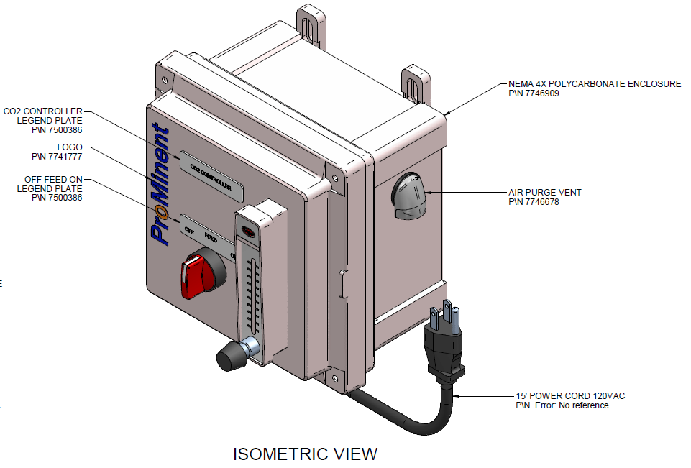
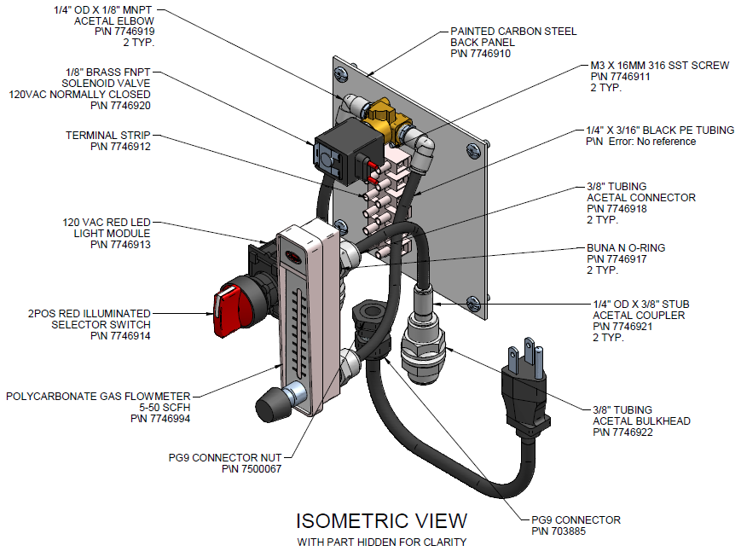

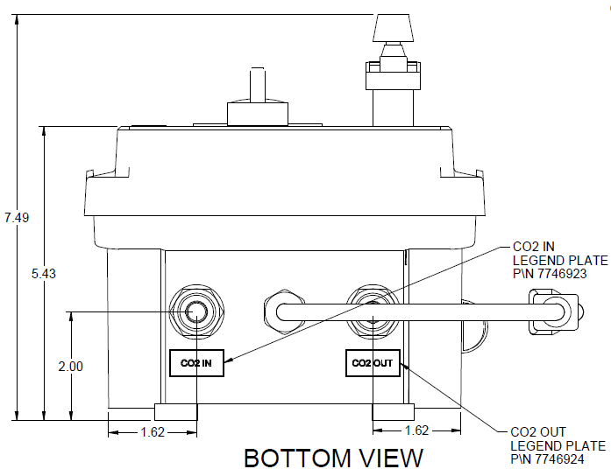

Electrical Schematic

Bill of Material

Part Number | Qty. | Description | CO2 Feeders
Part Number | Qty. | Description | 7746928 | 7746991
7746909 | 1 | FIBOX POLYCARB UL NEMA4X 6X6X4 ENCL | X | X
7746910 | 1 | FIBOX 6X6 PAINTED STEEL SUB PANEL | X | X
7746678 | 1 | VENT, AIR PURGE, HAMMOND SDV180 | X | X
7746912 | 1 | AUTO DIRECT, TERMINAL STRIP, BM-M094CS | X | X
7746920 | 1 | VALVE, SOLENOID, 1/8" FNPT, BRASS, ASCO | X | X
7746911 | 2 | SCREW, M3X16MM, 316, MCMASTER 90116A161 | X | X
7746919 | 2 | ELBOW, 1/4" OD TUBE X 1/8" MNPT, ACETAL | X | X
703885 | 1 | CONNECTOR PG9 BLACK (7735074.2) | X | X
7500067 | 1 | PG-9 Nut | X | X
7746922 | 2 | BULKHEAD, 3/8" OD TUBING, ACETAL | X | X
7746918 | 2 | CONNECTOR, 1/4" OD TUBING X 1/8" MNPT | X | X
7781266 | 2 | Tubing, black LDPE,UV stabilized,1/4x3/16 | X | X
7746921 | 2 | COUPLER, 3/8" STUB X 1/4" OD TUBING | X | X
7746994 | 1 | AIR FLOWMETER, 1/8", FNPT, 5-50SCFH |  | X
7746916 | 1 | AIR FLOWMETER, 1/8", FNPT, 20-200SCFH | X
7746917 | 2 | O-RING, .44IDX.062W, BUNA N, AS568A-013 | X | X
7746913 | 1 | SQ D 22MM RED LED LIGHT 120VAC N.O. | X | X
7746914 | 1 | SQ D 22MM 2 POS MAINT SEL RED KNOB | X | X
7741777 | 1 | 4" BLUE PROMINENT LOGO W/ORANGE "O" | X | X
7746924 | 1 | PLATE, LEGEND, CO2 OUT | X | X
7500386 | 2 | PHOENIX 0819330 UC-EMLP DEVICE LABEL | X | X
7740829 | 1 | POWER CORD 15' 18/3 SJTOW BLK W/ PLUG | X | X
7745305 | 1 | MOV ZA SERIES V180ZA1P NEWARK 58K7343 | X | X
7746923 | 1 | PLATE, LEGEND, CO2 IN | X | X

APPENDIX B – Reference Documents

Mechanical General Arrangement Drawings:
7746991-400 CO2-50 Controller 5-50 SCFH
7746928-400 CO2-200 Controller 20-200 SCFH
7746926-400 CO2-D-L Diffuser Low 5-50 SCFH
7746942-400 CO2-E Eductor

(Provided upon request)
**Documents noted in this section are not in this manual**

APPENDIX C – Accessories

P/N: 7746926 CO2-D-L Diffuser Low 5-50 SCFH [Only] (3/8” O.D. Tubing Inlet & ½” NPT Process Connection)

P/N: 7746942 CO2-E Eductor (3/4” MNPT Inlet/Outlet & ¼” MNPT or ¼” I.D. Tubing Barb)

P/N: 7746943 CO2 Heater (Power 120V, 60Hz)

P/N: 7747036 CO2 Brass Pressure Regulator
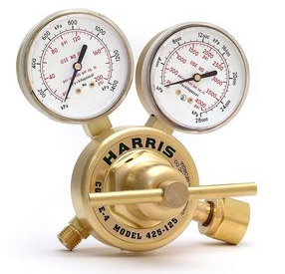

P/N: 7747037 CO2 Two Cylinder Manifold (Automatic Switchover)
-Includes Qty. One - P/N: 7747036 Brass Pressure Regulator
-Includes Qty. One – P/N: 7747031 Two Cylinder Manifold wCGA320 Connection
-Includes Qty. One – P/N: 7747035 Acetal ¼” FNPT x 3/8” OD Tube Fitting

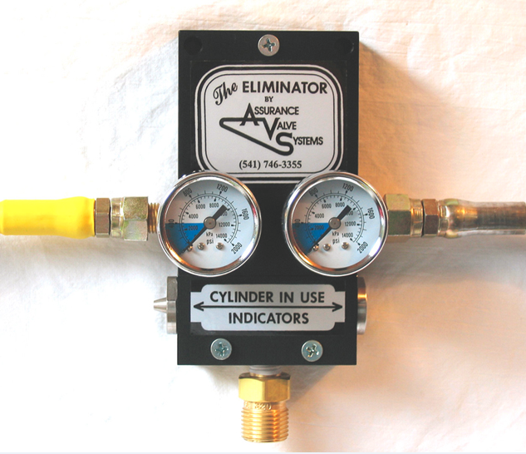

P/N: 7747038 CO2 Four Cylinder Manifold (Automatic Switchover)
-Includes Qty. One - P/N: 7747036 Brass Pressure Regulator
-Includes Qty. One – P/N: 7747032 Four Cylinder Manifold wCGA320 Connection
-Includes Qty. One – P/N: 7747035 Acetal ¼” FNPT x 3/8” OD Tube Fitting
(Unit is similar to Two Cylinder but has two connections on each side)

P/N: 7747039 CO2 Six Cylinder Manifold (Automatic Switchover)
-Includes Qty. One - P/N: 7747036 Brass Pressure Regulator
-Includes Qty. One – P/N: 7747033 Six Cylinder Manifold wCGA320 Connection
-Includes Qty. One – P/N: 7747035 Acetal ¼” FNPT x 3/8” OD Tube Fitting
(Unit is similar to Two Cylinder but has three connections on each side)

P/N: 7747040 CO2 Eight Cylinder Manifold (Automatic Switchover)
-Includes Qty. One - P/N: 7747036 Brass Pressure Regulator
-Includes Qty. One – P/N: 7747034 Eight Cylinder Manifold wCGA320 Connection
-Includes Qty. One – P/N: 7747035 Acetal ¼” FNPT x 3/8” OD Tube Fitting
(Unit is similar to Two Cylinder but has four connections on each side)

