NEW AUTOMATIC DISCOUNT DETERMINATION:

Starting with Quote Program V1.518 and above the application can automatically determine the correct discount percentage from PFC list price.

When the user enters a part number or changes a quantity the discount is determined based on customer number and product code.

The Main Quote Form has a new check box labeled: “Auto Disc”. If the user selects this check box (in the checked state) the Quote Program determines discounts automatically. The check box is turned off by default upon starting a quote editing session.

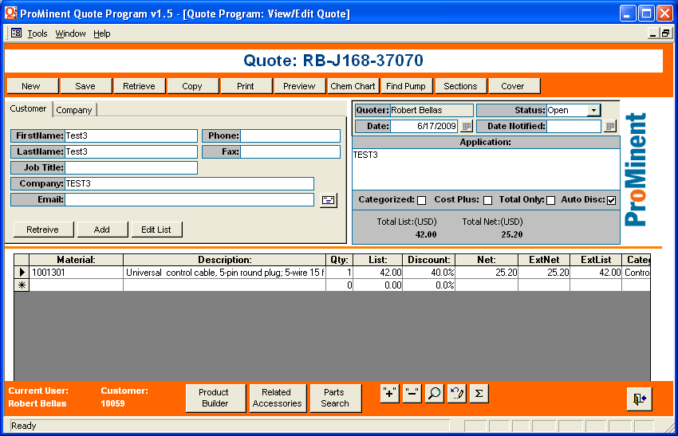

The customer number used in discount determination will be displayed on the bottom of the quote form next to the product builder button. If the customer number is not displayed, then the user must enter a customer number via the registration form. See below…..

Another new feature worth mentioning is the “update prices” button. (found near the bottom of the Main Quote Form) When the user clicks the button all the prices and discounts (if enabled) will be re-determined. This feature is most useful to the user when revising a quote that was created some years ago. The user can quickly update all the prices to be in agreement with the most current price list.

How to enter a customer number:

- Open the registration form:

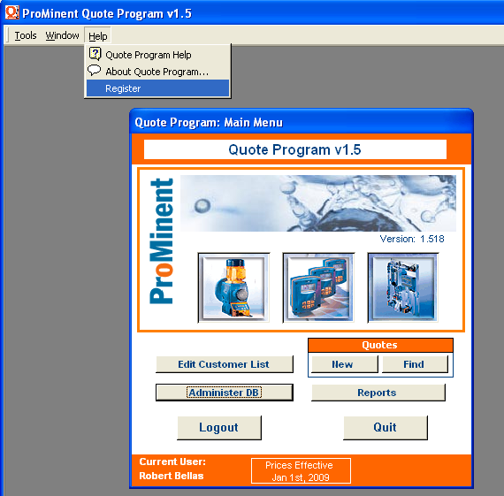
- Enter the PFC account number -- obtain the customer from an order confirmation or contact PFC. It is very important to enter the correct number, otherwise the discounts may not be determined correctly.

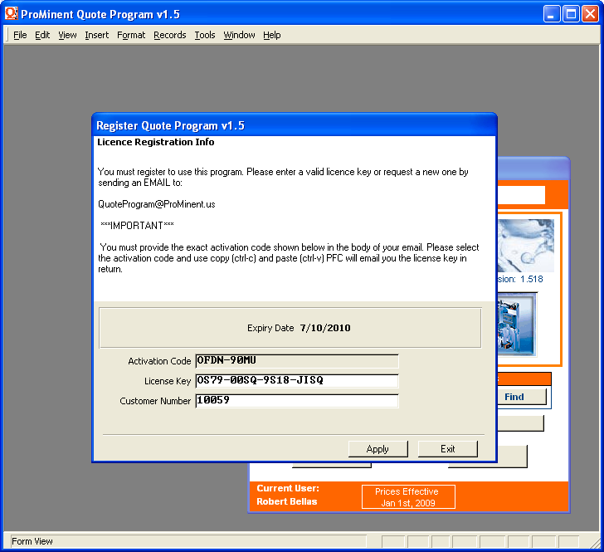

3) Enter the same customer number a second time for verification.

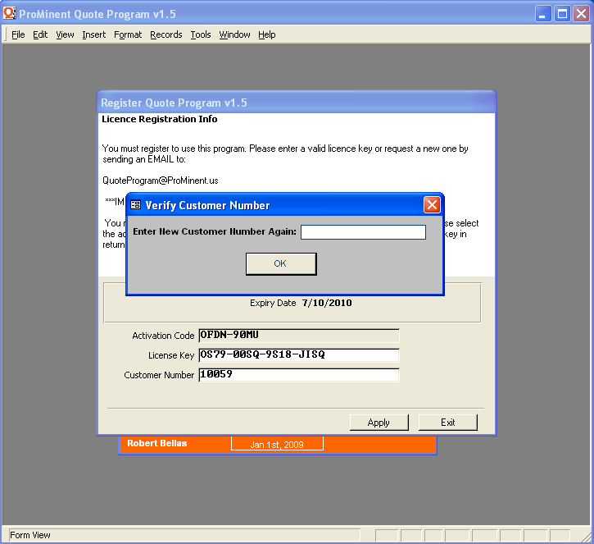
4) Finally hit the Apply button and then the Exit button.

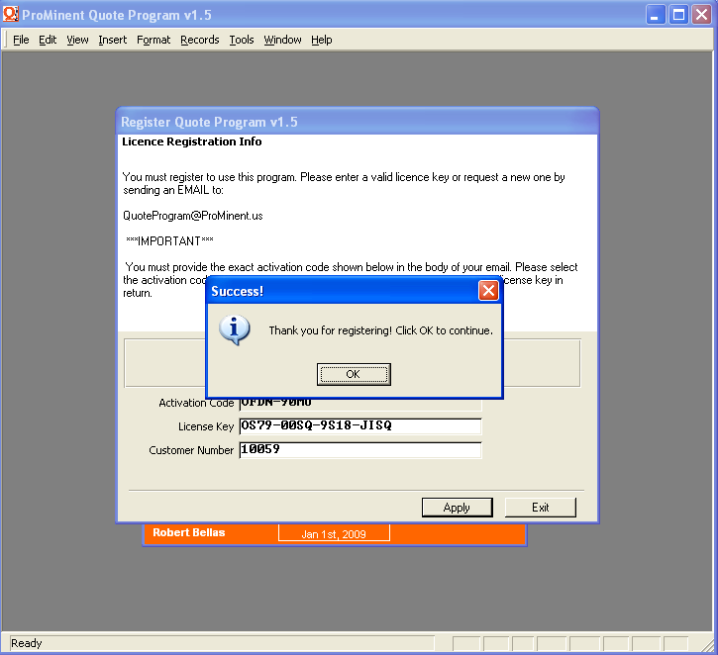
The customer number is now locked. The user may change the customer number in case of error, but only after agreeing to erase the existing license key. The user must register again after changing the customer number. Please do not change your customer number unnecessarily!!!!

