[How-To](https://www.groovypost.com/howto/)

**How To Enable .NET Framework 2.0 and 3.5 in Windows 10 and 8.1**

By [Brian Burgess](https://www.groovypost.com/howto/author/brian/)

Last Updated on January 7, 2019

Have you tried to install certain programs on Windows 8 and you get an error saying it needs .NET Framework 2.0? Here’s how to enable previous version of .NET so you can install and use those programs.

While using Windows 8 or Windows 10, I’ve found that a lot of older programs won’t install or run correctly because they require previous versions of .NET Framework. Here’s how to enable support for those versions of .NET Framework.

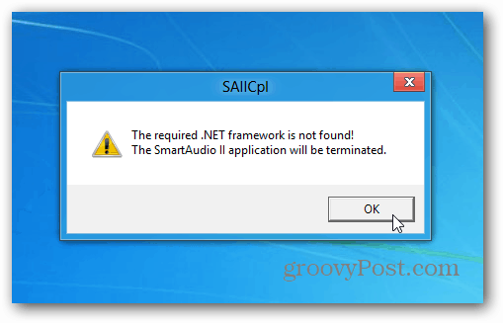

Some programs will want to download an older version of .NET Framework, but this doesn’t work. You still need to enable it.

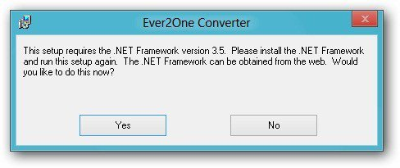

From the Windows 8 desktop, open the [power user menu](https://www.groovypost.com/howto/windows-8-power-menu-metro-start-screen/) and select Control Panel.  
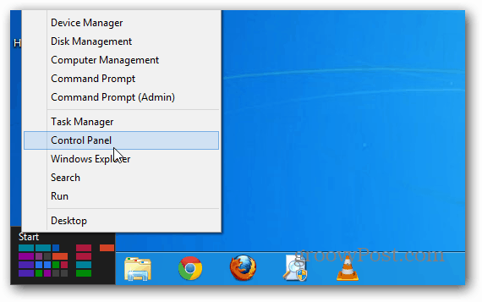

From the Control Panel, click Programs and Features.  
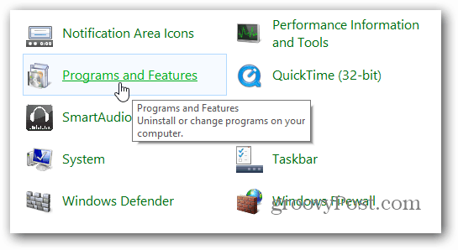

When the Programs and Features window comes up, click Turn Windows Features On or Off.

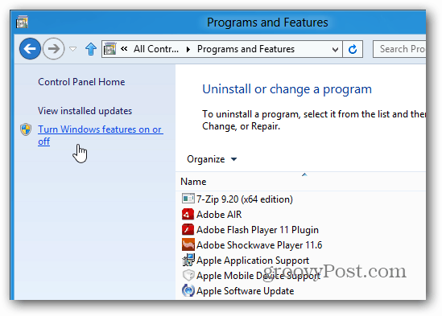

Then check .NET Framework 3.5 (includes .NET 2.0 and 3.0) and click OK.

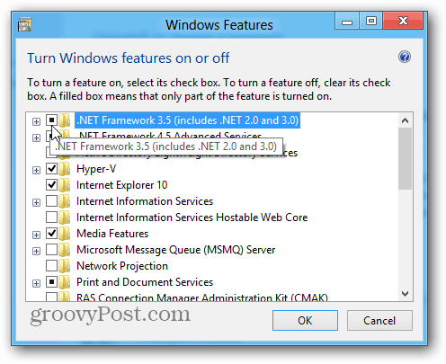

Next, you’ll need to download files from Windows Update.

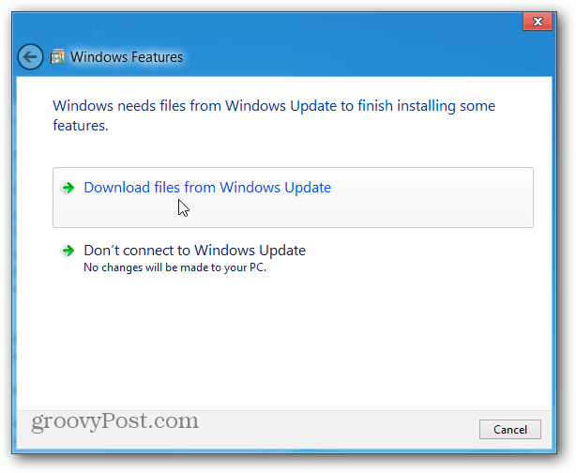

Wait while the previous versions of .NET Framework are downloaded and installed.

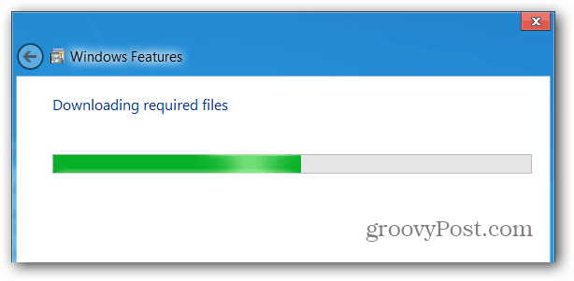

A restart might be required. I enabled previous versions of .NET on three different Windows 8 systems and my 32-bit version needed to be restarted.

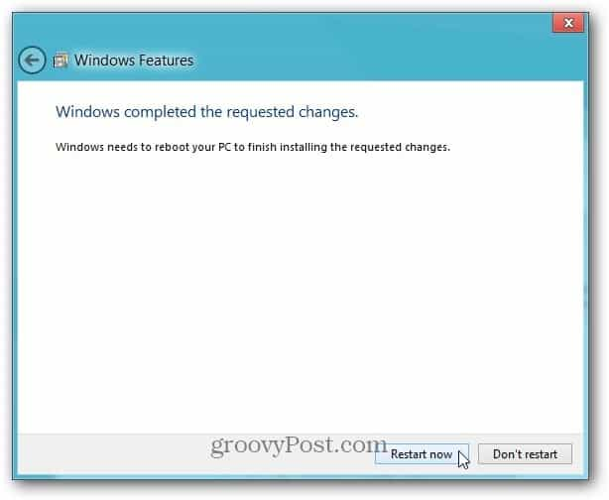

Now you can start using the programs that require the old versions of .NET Framework.