NewLogoCMYKOperating Instructions  
ProMinent® ProMix “S” Series  
Polymer Blending Systems

ProMix_S_Master_OM.docx (8/04/10): – pn. 7750262

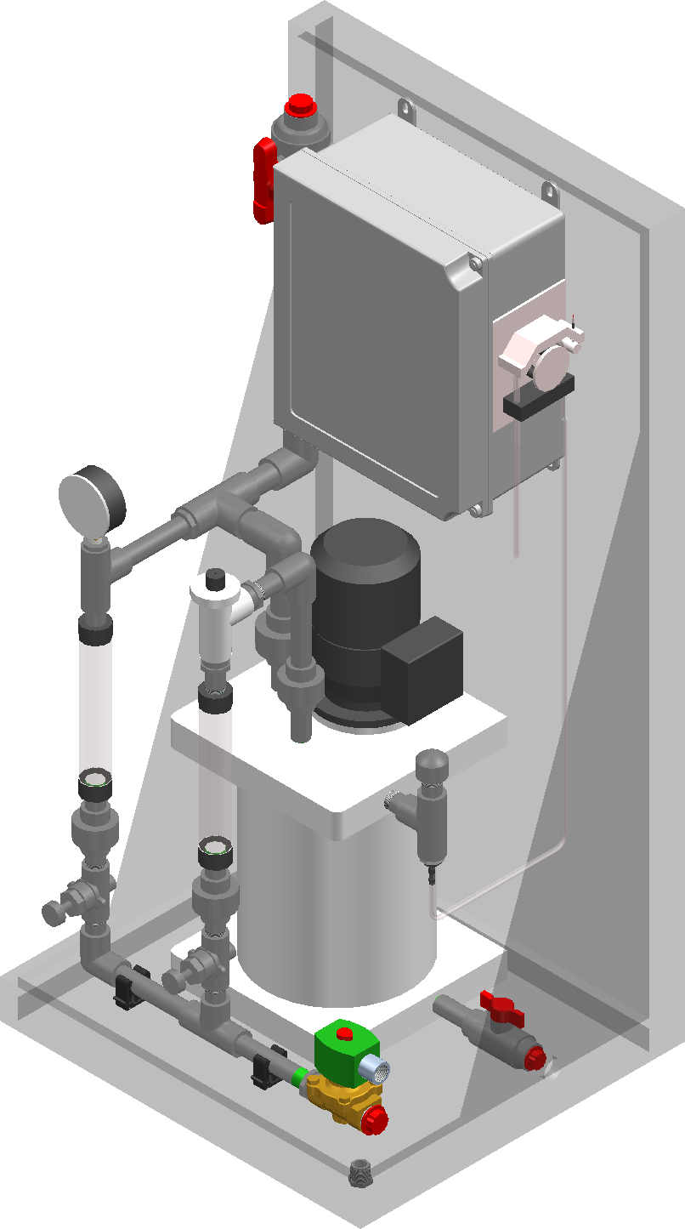

**Please completely read through these operating instructions first! Do not discard! The warranty shall be invalidated by damage caused by operating errors!**

ProMinent Fluid Controls, Inc. (USA) 136 Industry Drive, Pittsburgh, PA 15275

# Table of Contents

## Contents

## Specifications 3

##### Technical Data 3

## General Description (Figure 1) 4

## System Components (Figure 2) 5

## Layout Drawing (Figure 3) 6

## Installation 7

##### Unpacking 7

##### Location 7

##### Electrical Installation 7

##### Water Installation 7

##### Polymer Installation 7

##### Electrical Schematic (Figure 4) 8

##### Electrical Schematic Block Diagram (Figure 5) 9

Calculating Your Polymer Solution Feed Rate 10

Description of System Control 11

**Commissioning/Start up 12**

Operation 13

##### Manual Continuous Operation in “H” (HAND position) ………………………………………13

## Remote START/STOP Operation in “A” (AUTO position)……………………......................14

**Maintenance 15**

##### Polymer dosing pump 15

##### Cleaning the injection valve 16

##### Cleaning the mixing chamber 16

**Spare Parts 17**

# Specifications:

## Technical Data

Voltage supplied 120 VAC. 60 Hz, 1PH

Power: max 100 watt

Remote control: Voltage free contact + 4-20 mA

Volume of mixing chamber 1.9 gallon

Connection water: 3/4" FNPT

Connection polymer solution: 1/2" tubing

Polymer dosing pump type: Peristaltic (Tube) pump

Sound level: < 70dB (A)

Max. Backpressure, polymer solution 15 psi

Recommended running temperature +50 to100ºF

Weight (empty chamber): 71 Lbs

Internal diameter of the pump tubing 5.0 mm

# General Description

## General description

The ProMinent ProMix polymer system provides a complete activation and dosing system for concentrated polymers. The true Multi-Zone mixing chamber provides proper shear and mixing energy required for efficient activation of emulsion and dispersion polymers.

The system comes complete with mixing chamber, agitator, motor, neat polymer pump, rotameters, solenoid valve, flow switch, static mixer, and control panel all assembled on a polypro skid suitable for wall or floor mounting.

###### Figure 1

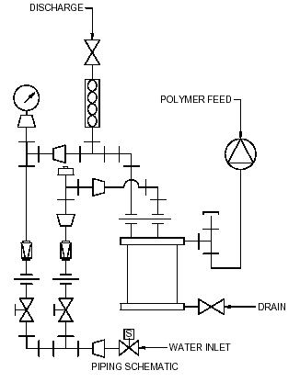

# System Components

**Figure 2**

# 

# Layout Drawing

**Figure 3**





# Installation

## Unpacking

* Unpack your ProMix. Make sure that your ProMix hasn’t been damaged during the transport. If it has, please report to shipping company. ProMinent is not responsible for damaged goods once they have left the factory.

## Location

* The ProMix should be placed in a dry location that is protected from the elements and be easily accessible for service and maintenance.
* The ProMix is configured for wall or floor mounting (see Figure 3). Make certain that the polymer unit is located near the neat polymer container and near the point of injection.

## Electrical Installation

* The ProMix is electrically connected according to the enclosed electrical diagram (see Figure 4 & 5). Make sure that the system is well grounded to prevent electrical shock.

## Water Installation

* Connect clean incoming water supply to inlet piping (see Figure 1).
* It is recommended to install the supplied pressure regulator close to the water supply solenoid valve.
* Operatingpressure should not exceed 30-35 psi. If supply source is higher, use of a pressure reducing valve is recommended.

## Polymer Installation

* Connect the supplied flexible tubing to the polymer pump fitting and the other end to the polymer supply source (drum, tote bin, bulk tank, etc.).

# Installation

**Figure 4**

# Installation

**Figure 5**

# Calculating Your Polymer Solution Feed Rate

**GPH Neat Polymer** / **Desired Solution Concentration** = **Dilution Water Requirement**

**Example:** 2.5GPH / 0.005 = 500GPH Dilution Water

*(This comes out to a ½% solution strength)*

**Total Solution Requirement** x **Desired Solution Concentration** =

**Neat Polymer Requirement**

**Example:** 1200GPH x 0.001 = 1.2GPH Neat Polymer Requirement

*(This is a tenth of a percent solution strength)*

# Description of System Control

“HAND” = Manual start and reset   
(polymer feed pump manual potentiometer speed control)

“OFF” = Off (turns unit off)

“AUTO” = Manual start and reset + external voltage free remote contact start/stop. Speed control via external 4-20 mA signal only.



* The control panel is assembled with all internal connections necessary to operate the system.
* The solenoid valve is opened and closed via the control switch “H-O-A”.
* The agitator and polymer feed pump starts and stops by the water flow via the flow switch, assembled on the preparation water inlet. The flow switch activates when water flows through the primary rotameter.
* The ProMix stops by turning the control switch on the control cabinet to position “O”.
* The auxiliary supply voltage is activated by pressing the push-button marked “Start/Reset” after first being placed in the “H” or “A” position. If the auxiliary supply voltage falls during operation, one or both of the thermal contacts has opened.

# Commissioning/Start Up

The polymer pump should not be running during the following procedure. Make sure that the potentiometer on the control cabinet indicates 000. If not, turn the potentiometer counter-clockwise until it shows 000.

* Ensure inlet water supply, neat polymer supply, and polymer solution discharge are connected to the ProMix (see Figure 1).
* Ensure that correct power is supplied to the ProMix (see Figure 5).
* Open the incoming water valve on the primary rotameter 100%.
* Ensure that the secondary rotameter is closed (if one is supplied).
* Operatingpressure should not exceed 30-35 psi. If supply source is higher, use of a pressure reducing valve is recommended.
* Turn on main breaker located inside control panel (see Figure 4).
* Start the system by turning the H-O-A switch on the control cabinet to “HAND” position.
* Press the “START/RESET” button to initiate water flow.
* When the water starts to flow at the discharge outlet, the system is primed.
* Reduce the flow by turning the primary rotameter valve until the mixer stops. (The flow switch inactivates during reduced water flow).
* Close the solenoid valve by turning the control switch to position “O” (off).
* The ProMix is now ready for service.

# Operation

Manual (Continuous) Operation in “H” (HAND position)

* Start your ProMix by turning the control switch to the “H” (HAND) position.
* The polymer dosing pump and the agitator start automatically by the activated flow switch located on the primary rotameter.
* Adjust the pump capacity and the amount of preparation water by using the Polymer Concentration tables. The concentration of the diluted polymer shall never exceed 0.5%. The table is designed around a product that contains 50% active polymer. This is valid for most emulsion and dispersion polymers.
* Adjust the polymer dosage according to your above result by turning the potentiometer on the control cabinet to a higher or lower value.
* Change the amount of dilution water by adjusting the flow through the primary and/or secondary rotameter.

## Remote START/STOP Operation in “A” (AUTO position)

* Start the polymer dosage by turning the control switch to the “A” (AUTO) position.
* The remote start / stop contact permissive switch must be closed.
* Push the START / RESET button.
* Increase or decrease the polymer dosage by changing the 4-20 mA external signal to a higher or lower value (4-20 mA = 0 – 100% pump speed). Change the amount of dilution water correspondingly. Use the Polymer Concentration tables to determine water and polymer flow rates.
* Stop the polymer dosage by turning the control switch to position “O” (OFF).

# Maintenance

## Polymer Dosing Pump

* The polymer dosing pump is a peristaltic pump for continuous duty. It’s equipped with flexible tubing with good mechanical and chemical qualities.
* The flexible tubing is assembled with the suction side tubing connection on the right side of the pump. The polymer discharge tubing is on the left side of the pump.
* The tubing should be changed after around 1,200,000 turns.
* Pump turns correspond to the number of operation hours as follows:

40 rpm (2400 rph) = 500 hours

20 rpm (1200 rph) = 1000 hours

10 rpm (600 rph) = 2000 hours

5 rpm (300 rph) = 4000 hours

2 rpm (120 rph) = 10,000 hours

* The polymer injection valve is located on the top of the ProMix. The injection valve must be cleaned when using different type polymers such as anionic/cationic or oil-based/water-based. Failure to do this can result in clogging of the injection valve.
* Before dismantling the injection valve, the fluid level in the mixing chamber must be lowered to prevent polymer spilling out of the injection port.
* Lower the fluid level in the mixing chamber by closing all ports and opening the flush drain valve located at the bottom of the chamber. Make sure that you connect tubing to the drain valve to prevent polymer spillage. Once the fluid level is below the injection valve, the valve can be disconnected for cleaning.

# Maintenance

## Cleaning the injection valve

* Assure that the liquid level in the mixing chamber is below the injection valve.
* Loosen the screws on the small oval lid on the top of the mixing chamber.
* Lift the lid using a screwdriver or similar tool.
* Carefully take out the injection valve.
* Unscrew the injection valve
* Clean the valve with a paper towel. Do not use water. A solvent can be used to clean valve if necessary.
* Check the O-Rings and replace if necessary.
* Clean the injection valve seat in a similar fashion.
* Reassemble the valve and check the spring for functionality before installing into chamber.

## Cleaning the mixing chamber

1. Adjust the potentiometer on the control cabinet to 000
2. Open the solenoid valve (the control switch in “HAND” position) and let the dilution water rinse the inside of the chamber while the agitator is running.
3. If emptying the chamber is necessary, shut off polymer pump and discharge outlet. Open the drain valve located at bottom of chamber and flush water through.

# Spare Parts List

|  |  |
| --- | --- |
| 1028761 | Stand, SS1, 40”X20”X18”, Black, PP\PE |
| 7500334 | Gauge, 0-200 PSI, 1/4" NPT BTM, 2" Face |
| 7746301 | 3/4” PVC Koflo Static Mixer |
| 7746302 | 3/4" Bronze Pres Reg w/Gauge Port |
| 7746303 | 1/2" PVC Needle Valve NPT |
| 7746304 | 2 gpm Rotameter 1/2" FNPT |
| 7746342 | 1 gpm Rotameter 1/2" FNPT |
| 7746343 | 5 gpm Rotameter 1/2" FNPT |
| 7746305 | ASCO NC Solenoid Valve 120V/60Hz |
| 7746306 | Asahi Omni NPT Valve PVC Cmpct |
| 7746307 | 1/4"x3/8"x1/16" PVC Tubing |
| 7746308 | 3/8"x1/2"x1/16" PVC Tubing |
| 7746309 | Nylon Tube Clamp 23/64"-25/64" |
| 7746310 | Nylon Tube Clamp 15/32"-17/32" |
| 7746311 | 3/8"x1/4" Union HB Blk HDPE |
| 7746312 | 1/4" x 3/8" Adapt HBxMNPT Blk HDPE |
| 7746313 | DIN Connector for ASCO Valve |
| 7746314 | Gems FS-500 Series Flow Switch |
| 7746222 | Circuit Breaker 15 Amp |
| 7745980 | 4PDT 5A Relay 120VAC |
| 7745711 | Weid WS16/2 1X1 1/4 Inch Fuse Terminal |
| 7746403 | 3-Position Selector Switch |
| 7746464 | Nema Contact Block |
| 7746360 | Injection valve |
| 7746356 | Pump tube id 8.0 x 550 mm (3.5 gph models) |
| 7746355 | Pump tube id 5.0 x 550 mm (0.15, 0.31, 0.79 gph models) |
| 7746354 | Pump tube id 5.0 x 500 mm (1.5 gph models) |
| 7746345 | Mixing chamber complete |
| 7746347 | (0.15 gph) Peristaltic Pump |
| 7746348 | (0.31 gph) Peristaltic Pump |
| 7746349 | (0.79 gph) Peristaltic Pump |
| 7746350 | (1.50 gph) Peristaltic Pump |
| 7746351 | (3.50 gph) Peristaltic Pump |