

Browser Manual
ProMinent® ProMtrac
Cooling Tower
Water Treatment Controller

ProMtrac_Browser_Manual.docx (5/23/13) rev1: – pn. 7501088

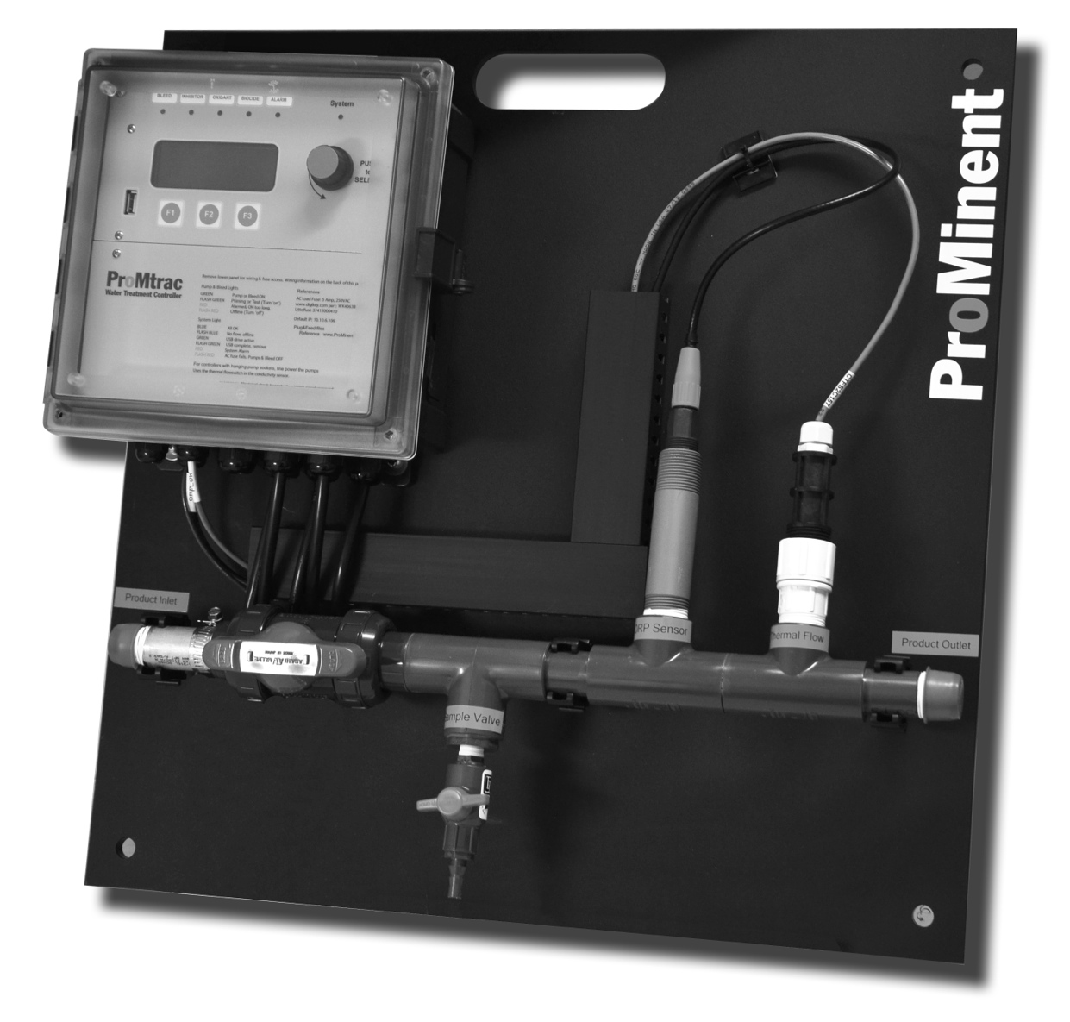

Please completely read through these operating instructions first! Do not discard! The warranty shall be invalidated by damage caused by operating errors!

ProMinent Fluid Controls, Inc. (USA) 136 Industry Drive, Pittsburgh, PA 15275

I/O Space Wiring Navigation

Sidebar:

The physical connection points for inputs & outputs are designated
by letters (A-K) for inputs & 4-20mA outputs & numbers (1-5) for control relays

Using letters & numbers provides a way to refer to wiring points and I/O locations while
allowing users to change the names of these location to fit their site.

For Example: The bromine feed may be user labeled ‘Feeder 123’ but the wiring
location is always Relay No.3 & a ‘3’ tags the browser pages & the LCD displays

Login Browser Navigation 1 of 3

On-Site using a Notebook PC to a ProMtrac not on the Site LAN
- You’ll need an Ethernet patch cable & a crossover adapter available
from office supply & electronics stores; Example: Office Depot #942378,.

B. You’ll need to set up a new connection in your notebook or PC.
Refer to Connect @ end of manual

Open the controller enclosure door, remove the lower access panel and jack into the controller Ethernet jack located @ the bottom center of the controller circuit board.

Start Internet Explorer or Mozilla’s Firefox.

Notebook PC & Over the Site LAN
Key the controller IP address into the PC’s browser address.
You can find the controller’s IP address using the controller keypad (default = 10.10.6.106).
Refer to Connect @ end of manual.

Login Browser Navigation 2 of 3

Note: Views are optimized for limited resolution displays,
notebook & netbook PCs at 1024 x 768 pixels.

Default Passwords:
The factory default userids & passwords are:
Operator1 = 1 Operator2 = 2 Operator3 = 3 Operator4 = 4.
Configure5 = 5 Configure6 = 6 Configure7 = 7 Administrator = AAAA
There are 3 password levels, Operator, Configure and Administrator.
The User IDs are used in the controller’s keypress log.

WARNING: 5 incorrect passwords, blocks logon until 7:00AM or until a power OFF/ON.

Login Browser Navigation 2 of 3

The selector at the top, right side of the browser page navigates to both System & I/O pages.

System Configure - Diagnostic

System Ethernet

System View Icons

System Passwords

System Time & Date

Sensors Calibrate

Sensors Configure 1 of 2

Sensors Configure 2 of 2

Sensors Alarms 1 of 2

Sensors Alarms 2 of 2

Sensors Diagnostic 1 of 2

Sensors Diagnostic 2 of 2

Sensors 4-20mA Outputs

Controls Auto / Prime / Stop

Controls Setpoint 1 of 2

Controls Setpoint 2 of 2

Controls Configure 1 of 4

Controls Configure 2 of 4

Controls Configure 3 of 4

Controls Configure 4 of 4

Controls Alarms 1 of 3

Controls Alarms 2 of 3

Controls Alarms 3 of 3

Controls Biocide Feed Events

Controls Diagnostic

Connect Ethernet Set-up 1 of 3, Windows

Windows operating systems have a simple way to find the Ethernet setup parameters:

You can use either the Keypad-LCD interface or the browser to setup the controller’s IP Address, Netmask, Gateway & Primary DNS.

Connect Ethernet Set-up 2 of 3, Windows 7

Connect Ethernet Set-up 3 of 3, Windows 7

