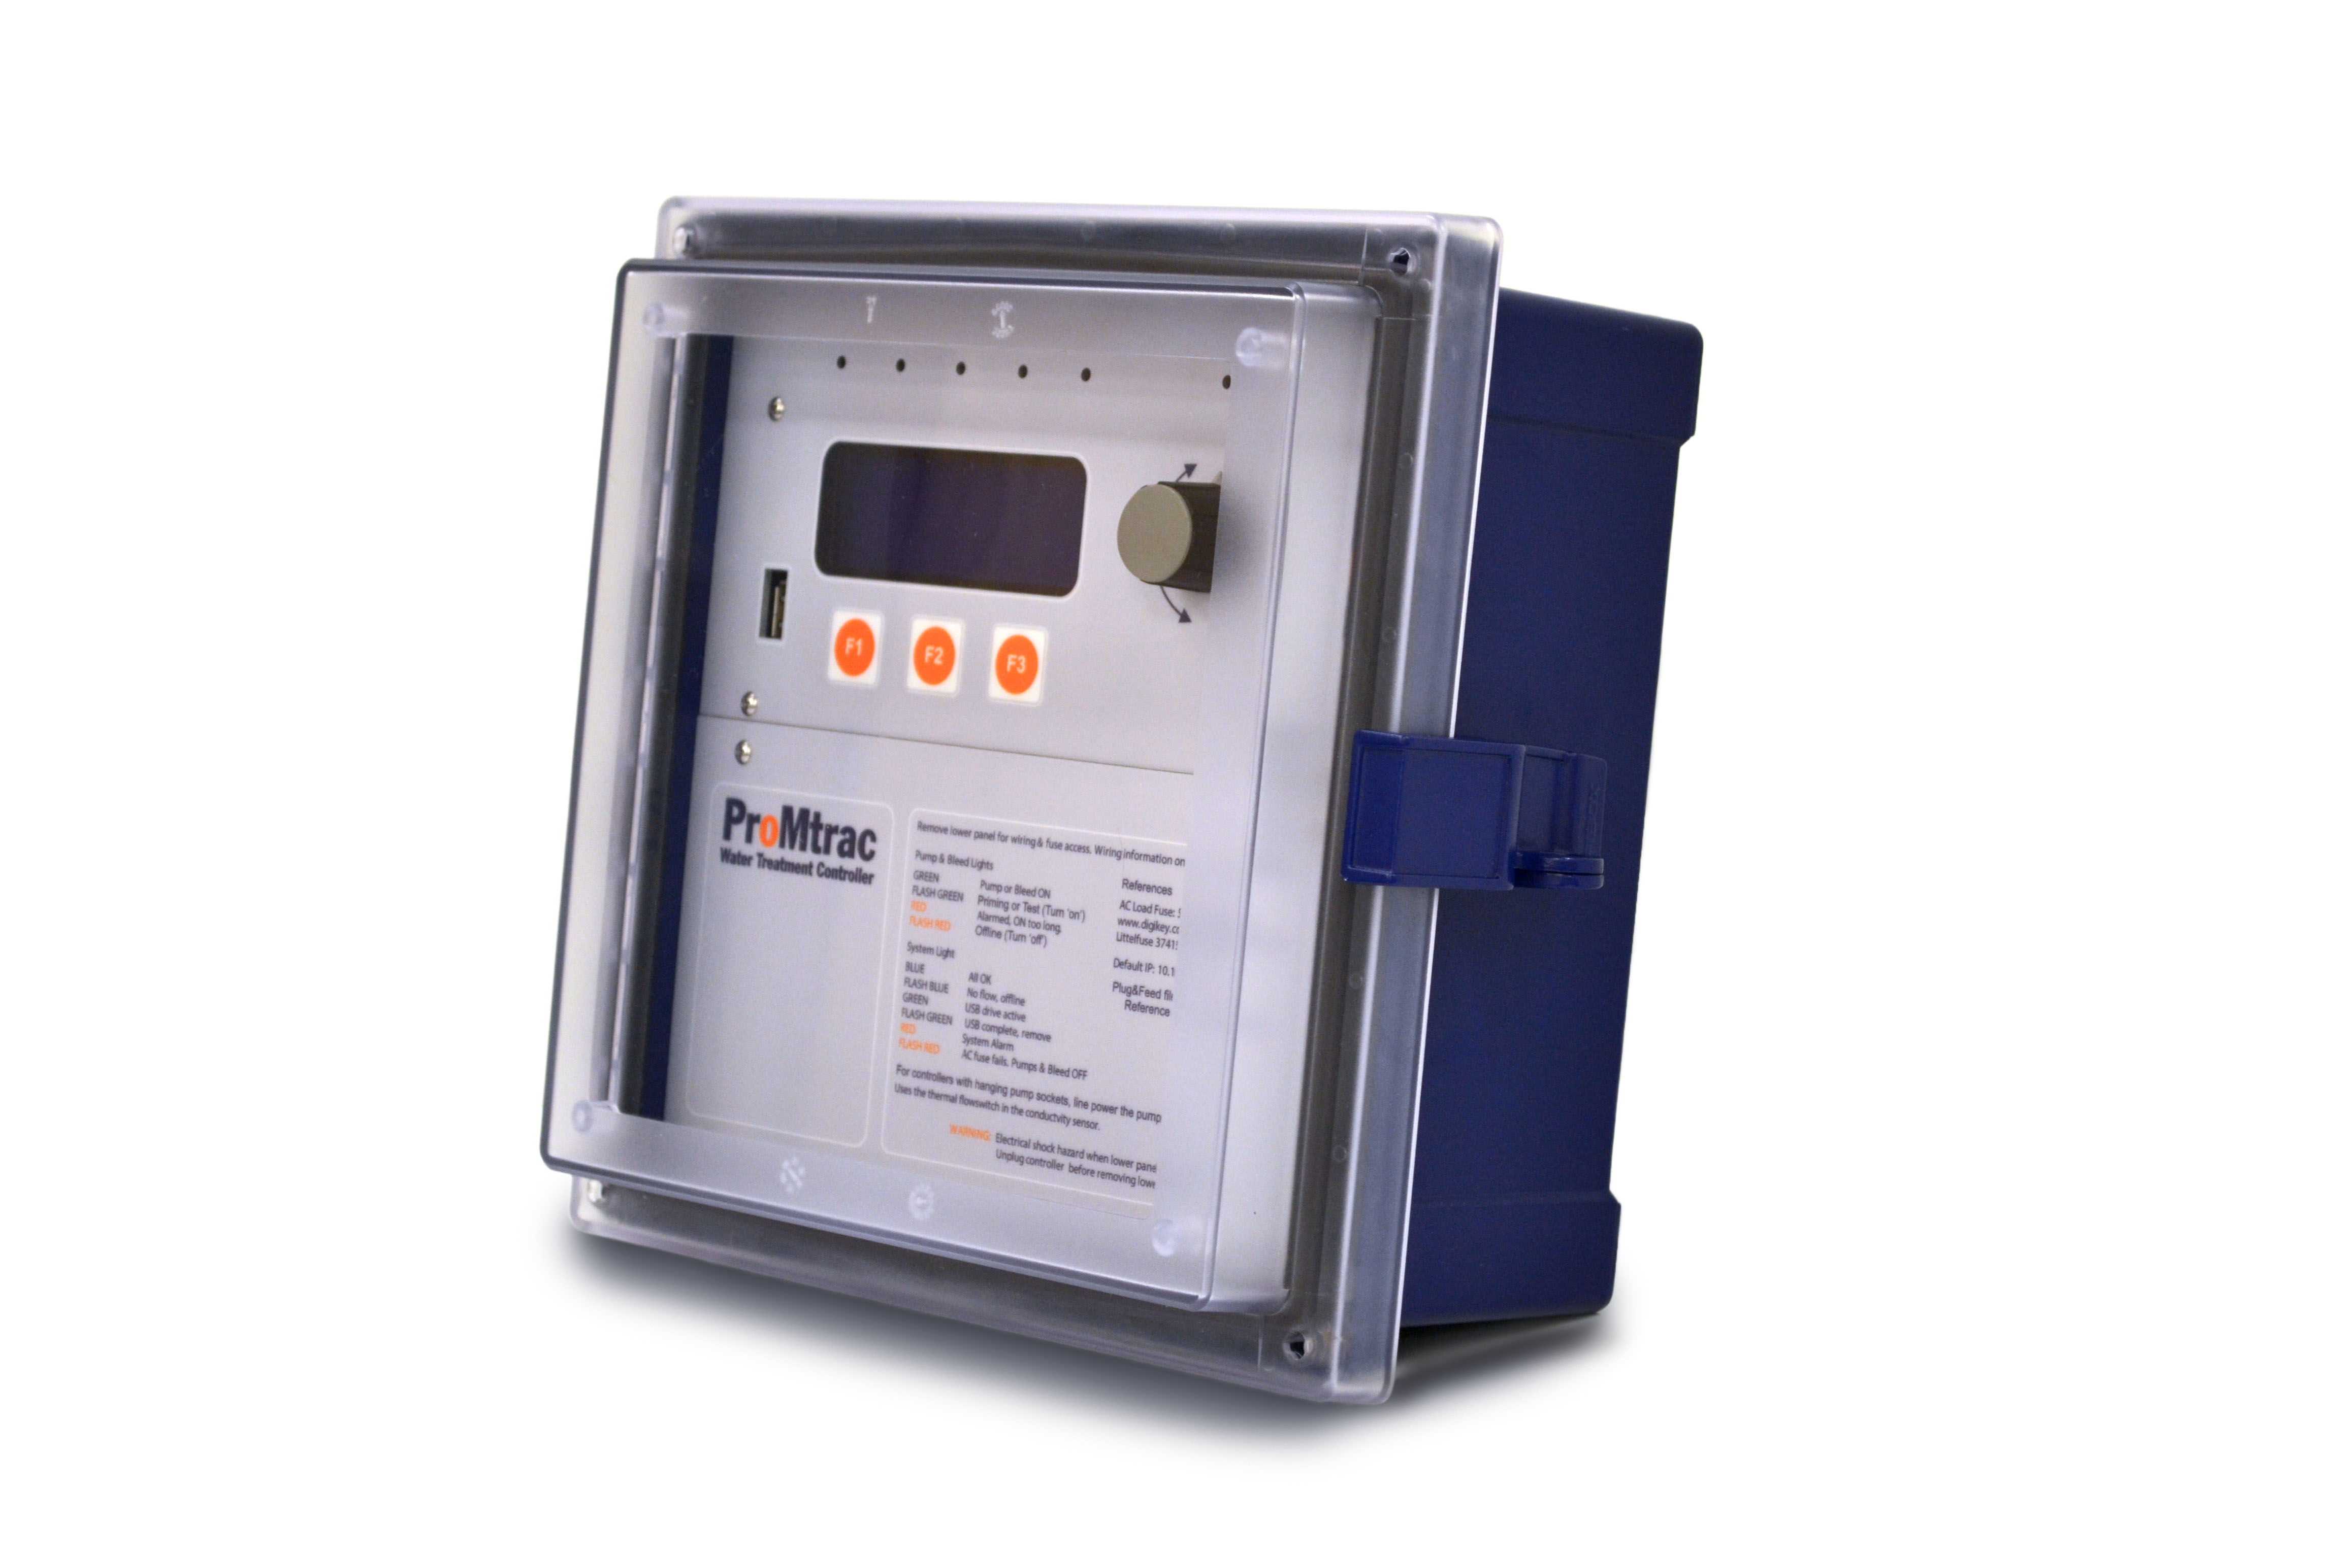
ProMtrac

Cooling Tower
Water Treatment Controller

Quick Start Guide
P/N: 7501033 - Rev1 - 5/16/13

SPARE PARTS

7500979 COND/TEMP/FLOW ASSEMBLY (Probe only 7761529)
7500980 COND/TEMP/FLOW ASSEMBLY HIGH PRESSURE (Probe only 7761533)
7500850 FUSE
7500790 4-20mA OUTPUT DRIVER CARD
7500791 pH or ORP DRIVER CARD
7501032 4-20mA ISOLATED INPUT DRIVER CARD
7501031 MAIN ELECTRONIC CIRCUIT BOARD
7500727 LITTLE DIPPER FLUOROMETER
7500725 100 PPB CALIB FLUOROMETER CALIUBRATION STANDARD

INSTALLATION

Mount the controller on a wall at eye level in an environment free of dust and condensation. Temperature limits are 32º to 120º F. Enclosure is rated Nema 4X. Power supply requirements are 120 VAC 60 Hz – a power cord is supplied with the controller. Inputs and Outputs are field wired through the connectors on the bottom of the controller box. Not all I/O is used so only the accessories required for the application should be terminated. To access the terminals remove the lower panel by loosening the two screws in the lower left and right corners, and lifting the bottom panel outward. Follow the wiring convention shown below which is on the back of the bottom panel.

DOOR LED DISPLAYS

Lights on the controller top panel indicate relay and system status.

DOOR LCD DISPLAY

All information and menus are displayed by the 4 line LCD on the controller door. Additionally there are up to five relay lights indicating relay status and one system light. A browser connection offers a graphical HMI view.

USB DRIVE

The USB port allows the use of a flash drive to download a configuration file for an application, upload and save a configuration file, upload data, and store the user and browser manual for easy reference (see section 12 of the user manual).

NAVIGATION

Changing configurations, setpoints, and alarms is possible using either the keypad/knob on the front of the controller or by using the browser. The browser can be used via a laptop connected directly or through Internet Explorer using the controller’s Ethernet port (recommended for configuration).

- Keypad and knob (see user manual section 1.2) (2) Browser (see separate browser manual)

CONFIGURATIONS

Inhibitor Control Method Options (see section 6 of user manual):

- Make up meter – Make-up water meter measures untreated water coming into tower system. User enters ppm inhibitor target set point to be maintained. Maintains a fixed volume ratio of make-up water to inhibitor.

- Bleed & Feed - Whenever the Cooling Tower bleeds water the Chemical pump adds inhibitor. Whenever you open the solenoid valve to bleed down the tower you add chemical at the same time. Some of the chemical goes down the drain. If you know bleed rate you can feed to compensate for lost inhibitor.

- Bleed then Feed - The Chemical Pump adds inhibitor for as long as the Cooling Tower bleeds water AFTER the bleed has turned off. If you bleed the tower for five minutes, you’ll pump chemical for five minutes as soon as the bleed finishes. You’re never pumping chemical down the drain.

- Bleed meter – Bleed water meter measures treated water discharged from the tower. User enters ppm inhibitor target setpoint to be maintained. Maintains a fixed volume ratio of bleed water to inhibitor.

- Percent Time – Pump feeds for percentage setpoint time on while flow switch is on. User sets mL/min for constant feed rate. Chemical feed is independent of conductivity control. Provides slugging for start-up passivation and accurate base feeding for sites with maintenance problems.

- Fluorescent ppm - Pump feeds based on a ppm setpoint of fluorophore in the inhibitor chemical to be dosed.

Bleed Solenoid (see section 6 of user manual):
Can be controlled by conductivity, make-up/bleed meter, tower/make-up ratio, make-up meter, percent time

Oxidizing Biocides (see section 6 of user manual):
Set up schedule for timed feeds, set pre-bleed time, change ORP setpoint (if ORP sensor used)

Non-Oxidizing Biocides (see section 6 of user manual):
Set up schedule for timed feeds, set pre-bleed time, set lockout times

Water Meters (see section 6 of user manual):
View and modify meter type, scaling, zero meters

4-20 mA outputs (see section 6 of user manual):
Optional based upon additional card, select 0-100% = 4-20 mA for sensor values, manual out option

BIOCIDE EVENTS
Set up 28 day event schedules for start and end times for Biocide A and Biocide B (see section 5 of user manual):

ADJUST SETPOINTS
Adjust bleed solenoid valve operation and inhibitor pump based upon control method (see section 2 of user manual):

ADJUST ALARMS
Adjust alarm points & limits for conductivity, inhibitor pump, makeup meter, bleed solenoid (see section 4 of user manual):

