

Installation & Operating Manual
ProMinent® ProMtrac
Cooling Tower
Water Treatment Controller

ProMtrac_OM.docx (5/23/13) rev1: – pn. 7501089

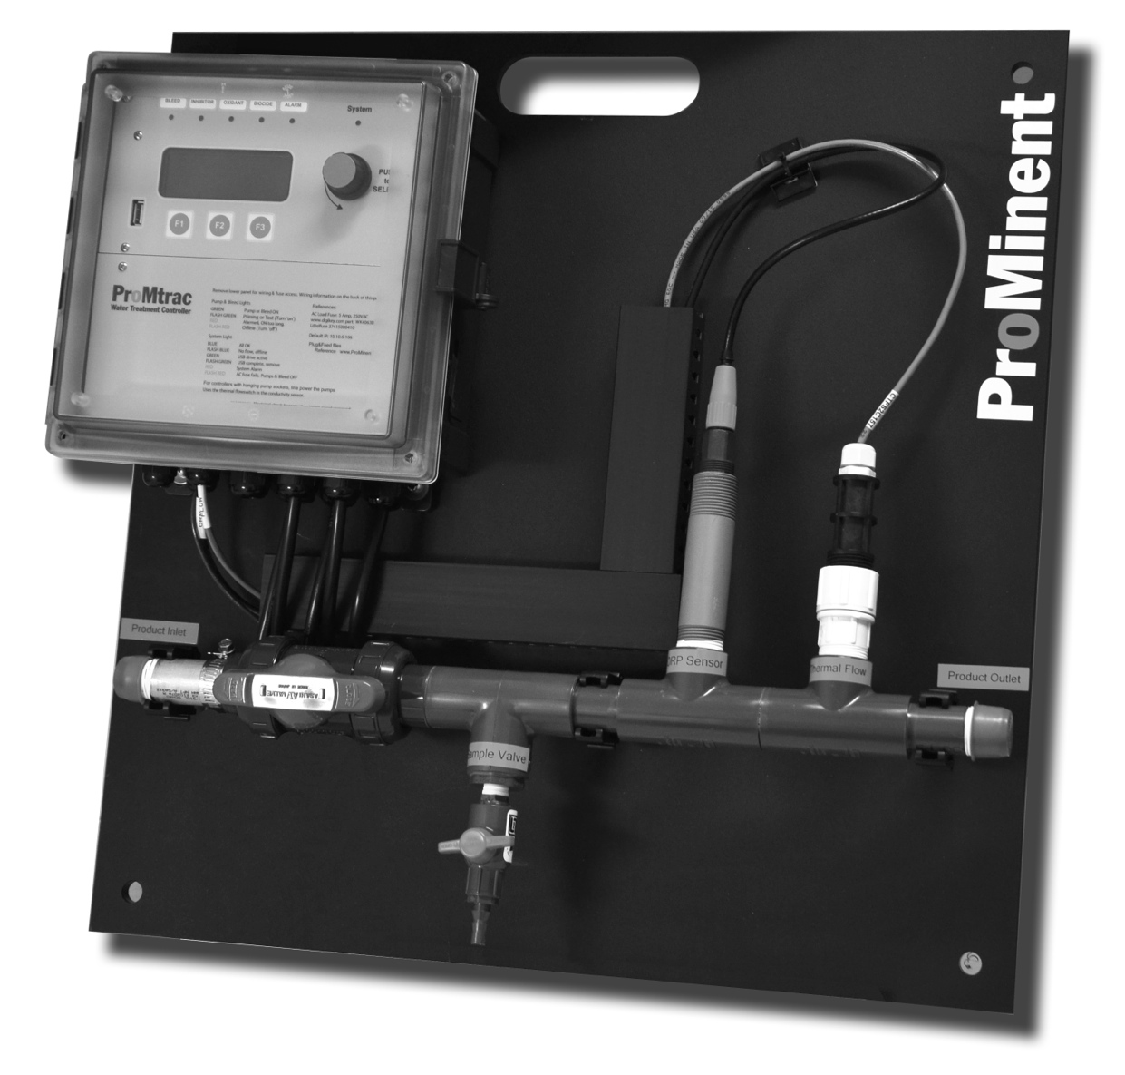

Please completely read through these operating instructions first! Do not discard! The warranty shall be invalidated by damage caused by operating errors!

ProMinent Fluid Controls, Inc. (USA) 136 Industry Drive, Pittsburgh, PA 15275

CONTENTS

Safety

1. Navigation
1.1 Power ON display
1.2 User Menus
  - Status Displays
  - Browser View

2. Adjust Setpoint Bleed Solenoid, Inhibitor Pump

3. Calibrate Conductivity

4. Adjust Alarms Conductivity, Inhibitor Pump, Water Meters,
Bleed Solenoid

5. Biocide Events

6. Configure Inhibitor Pump, Bleed Solenoid, Oxidant Pump
Biocide ‘B’, Make-up Meter

7. 4-20mA Outputs

8. Passwords

9. Power Wiring

10. Dry Contact Pump Wiring

11. Sensor & Water Meter Wiring

12. USB flash drive data logs & configuration files

13. Ethernet View-Modify

14. Relay Assignment



Safety Electrical Shock Hazard

Removing the lower faceplate panel with the controller plugged in,
exposes the user to AC power line voltages.

 USER WARNING : CAUTION

Water Treatment Controllers operate water valves and may pump hazardous, corrosive and toxic chemicals.

Removing the internal faceplates exposes the user to the risk of electrical
shock at power line voltages.

Understand fully the implications of the control methods, setpoints
and alarms that you select. Harm to personnel and damage to equipment may result from mis-application.

Unplug or turn OFF the AC power to the controller if you have any concerns regarding safety or incorrect controller operation and notify supervisory staff.

YOUR CONTROLLER
ProMtrac controllers are supplied in different configurations, part numbers and sensor sets. This manual includes information on optional components that may not be included with your controller

The WIRING section includes the information for terminating the sensor, water meters, AC power, pumps & solenoids

  - Power Up Display

The sensors on the 2nd line of the power up display vary with the installed sensor set.
pH or ORP have precedence followed by inhibitor ppm sensors and then make-up conductivity.

The value of each sensor, water meter, solenoid and pump can be viewed by pressing STATUS or by using the menu which displays on rotation.

OK, No Alarms alternates with the flow switch ON time.

1.2 User Menus

Use the rotary dial to view user menus

1.2 User Menus

Press @ System Settings navigates to:

Press @ other menu options navigates to the selected I/O.
Selecting STATUS at the Power ON display scrolls thru all I/O

1.3 Status Displays

1.3 Status Displays
1.3 Status Displays

1.4 Browser View

ProMtracs include a built-in command & control web server with a real time view of your controller operation.

You can browse with Mozilla’s Firefox or Internet Explorer over an Ethernet connection.
Modifying the controller requires a login.

Disabled inputs are automatically removed from the browser view.
User may switch icons to reflect their site’s usage.

See the ProMtrac Browser Manual for detailed information.

2. Adjust Setpoints

2. Adjust Setpoints

3. Calibrate

4. Adjust Alarms
4. Adjust Alarms
4. Adjust Alarms

4. Adjust Alarms
5. Biocide Events
5. Biocide Events

6. Configure
6. Configure
6. Configure
6. Configure

6. Configure
7. 4-20mA Outputs
7. 4-20mA Outputs

8. Passwords

8. Passwords

9. Wiring

Sensor and controls may be renamed by users. Each I/O is also tagged by a letter, ‘A’ to ‘K’ for inputs
& 4-20mA outputs and numbers ‘1’ to ‘5’ for control relays so that wiring locations can be connected to user I/O names.

Sensors A:Conductivity, F:Temperature, & H:Make-up Meter exists in every ProMtrac controller.
Sensors: B:Make-up Conductivity, C:pH or ORP, D:4-20mA Input or Output, E:4-20mA Output
are optional sensors
Sensors: G: Manual Input, I: Bleed Meter & J:Tank Level switch may be user enabled-disabled.
Sensor: K:Thermal Flowswitch may be disabled by making J the flowswitch.

9. Wiring

Open the enclosure door, unplug the power cord & remove the lower faceplate:

North American ProMtracs are supplied with a prewired power cord
& 120VAC for the bleed solenoid and 3 or 4 pumps.

If the Alarm relay #5 may be used for control, as a 120VAC switch on alarm or as a
dry contact alarm relay.

9. Wiring
Hint:
use a wire ring lug connector to bond the AC ground to other GREEN ground wires
Open the enclosure door, unplug the power cord & remove the lower faceplate:

9. Wiring

Open the enclosure door, unplug the power cord & remove the lower faceplate.
If relay 5 is not used as an alarm relay, it may be reconfigured to control a pump.

9. Wiring
Open the enclosure door, unplug the power cord & remove the lower faceplate.
If relay 5 is not used as an alarm relay, it may be reconfigured to control a pump.

10. Dry Contact Pump Wiring

Open the enclosure door, unplug the power cord & remove the lower faceplate:
If relay 5 is not used as an alarm relay, it may be reconfigured to control a pump.

11. Sensor & Water Meter Wiring

Open the enclosure door, unplug the power cord & remove the lower faceplate:

Tower and make-up conductivity sensors are identical & may be interchanged.
PromTracs are typically shipped with the tower sensor connected.

All sensor, meter & 4-20mA in-out terminal blocks are 2 piece.
The block can be removed to make it easier to connect wiring.

11. Sensor & Water Meter Wiring

Open the enclosure door, unplug the power cord & remove the lower faceplate:

Flowswitch choice: Users may select to use the thermal flowswitch built into the tower conductivity sensor or a dry contact set connected as shown in the flowing graphic.
Select is a System Settings / Site Options (see 1.2 User Menus).

11. Sensor & Water Meter Wiring

Open the enclosure door, unplug the power cord & remove the lower faceplate:

11. Sensor & Water Meter Wiring
Open the enclosure door, unplug the power cord & remove the lower faceplate:

12. USB Flash Drive Data Logs & Configuration Files

WARNING: Relays 1 to 5 turn OFF when the flash drive is inserted
Plug an HP v125w type flash drive or any compatible FAT32 formatted drive into the USB socket.
The time span of the log file is user selected @ System Settings / Site Options
(see 1.2 User Menus).

13. Ethernet View-Modify
13. Ethernet View-Modify

14. Relay Assignment

All units are shipped with the relays configured so that the front top controller panel
displays the assigned relay captions in the windows associated with these functions, and indicate the status of each relay by the color of the LED immediately below each individual window (see page 4). Relays are numbered 1 - 5 from left to right.
BLEED
ALARM
INHIBITOR
OXIDANT
BIOCIDE

It is possible to change the relay configuration if required by the application. The LED window captions can be changed by first turning power off to the controller and then removing the top panel. Inserted into the top edge of this panel is the paper legend ‘A’ or ‘B’ shown below which can be removed by pulling the folded paper tab upward.

A

BLEED INHIBITOR OXIDANT BIOCIDE ALARM

In addition to the original factory configuration, additional paper legends are included with the controller for possible field changes – they are marked on the tab as shown below: ‘B’ for pH with biocide, ‘C’ for ORP and no biocide, ‘D’ for pH and no biocide, and ‘E’ for two biocides.

B
BLEED INHIBITOR ACID BIOCIDE ALARM

C
BLEED INHIBITOR OXIDANT ALARM

D

BLEED INHIBITOR ACID ALARM

E
BLEED INHIBITOR BIOCIDE A BIOCIDE B ALARM

SPARE PARTS

7500979 COND/TEMP/FLOW ASSEMBLY (Probe only 7761529)
7500980 COND/TEMP/FLOW ASSEMBLY HIGH PRESSURE (Probe only 7761533)
7500850 FUSE
7500790 4-20mA OUTPUT DRIVER CARD
7500791 pH or ORP DRIVER CARD
7501032 4-20mA ISOLATED INPUT DRIVER CARD
7501031 MAIN ELECTRONIC CIRCUIT BOARD
7500727 LITTLE DIPPER FLUOROMETER
7500725 100 PPB CALIB FLUOROMETER CALIUBRATION STANDARD

